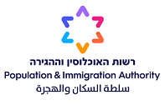
Public Tender with Two-Stage Process No. 10/2024
for the Supply of Inlays for Biometric Travel Documents

The Population and Immigration Authority of the Israeli Ministry of Interior hereby announces with respect to the above Tender as follows:

Requests for clarifications can be sent by e-mail to michrazim@piba.gov.il until May 27th, 2024.

Last date for submission of Bids to the Tender has been extended to until no later than June 18th, 2024, at 13:00 (Israel time).

This notice contains general and preliminary information only and the binding version is provided in the Tender documents.

